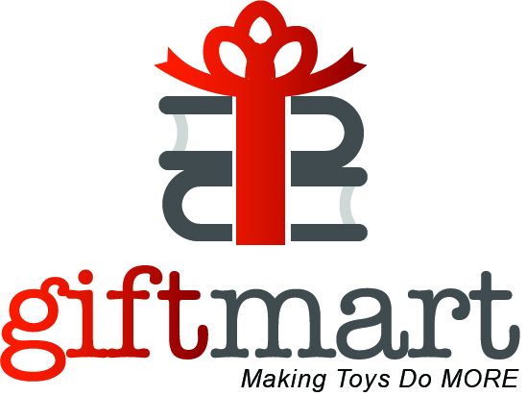

WISH LIST OF TOYS

Scooters
Skate board
Transformers
Nerf Guns
Marvel Action Figures
Fortnite Monopoly
Fortnite Battle Game Royale Save the World Action figures toy 8 piece set
Fortnite POP! Vinyl Figures
Fingerlings Interactive Baby Monkey or Unicorn or Blue Glitter Panda or untamed Dinosaur toys
Buffalo Games Skee Ball @ Target
Crayola Color Chemistry Lab Set
Over the ear headphones
Bluetooth speakers
Helmets
Hasbro Connect 4 Shots Game
Hasbro Don't Step in it Game
Lego Make your own Movie
Escape Room in a Box
Choose Kind Pop Socket or other PopSockets
Creative Roots Create your own unicorn garden
Pokemon Power Action Pikachu
Pomsies Speckles Plush Interactive Toy
L.O.L. Big Surprise
Hasbro Hearing Things game

]

