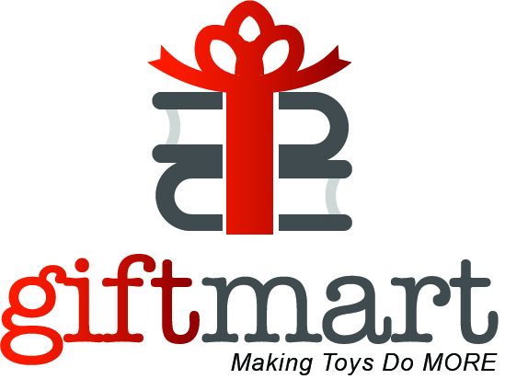

WISH LIST OF TOYS

Scooters
Skate board
Transformers
Nerf Guns
Our Generation Dolls
Frozen 2 toys and dolls
Toy Story 4
American Beauty dolls
Baby Alive
Remote control cars/trucks
Over the ear headphones
Crayola Color Chemistry Lab Set
Bluetooth speakers
Pomsies Speckles Plush Interactive Toy
Musical Instruments
Lego Star Wars
Sports Equipment
Hair Chalk
Hand Held Game Devices

]

